**Dreaming of a professionally recognised, rewarding career in Aeronautics?**



**Acquire Practical Skills In Aircraft Maintenance  
&  
Prep Course For EASA Part 66, Module 6 & 7 Exams**May 2013 or November 2013 Intake

@

IAP’s Tianjin Campus, People’s Republic of China  
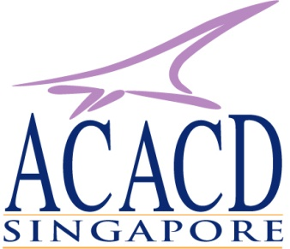

Program offered in collaboration with the above partners

European Aviation Safety Agency’s EASA Part 66 Category B  
Module 7 (with Module 6)

Maintenance Practices(with Materials & Hardware module)  
( 2 months of practical skills training)

**Available in IAP’s Approved 147 Facilities, Tianjin Campus, China**

Objectives:

a) For applicants who are interested to gain hands-on, practical experience in aeronautical maintenance for enrichment and career growth;

b) For applicants enrolling for the full-time Licensed Aircraft Maintenance Engineer Program sitting for this module as an integrated part of the whole EASA Part 66 professional programme;

c) Preparation course for EASA Part 66, Modules 6 and 7 examinations.

For Whom:

Academic Qualifications:

a. Sijil Tinggi Persekolahan Malaysia (STPM) OR GCE ‘A’ Level  
b. Polytechnic diplomas  
c. Non-technical personnel in the civil aviation industry   
d. Aircraft Maintenance Technical personnel with at least  
 two years of work experience in the industry  
  
CERTIFICATE: Certificate of Recognition   
  
Application Fee: S$50. (There is also registration fee upon placement).  
  
APPLY NOW for intake commencing in May 2013  
  
Please download and complete the “Registration Form” from our website  
at: [http://www.aaap-sg.net](http://www.aaap-sg.net.com) and fax to: +65 6741 1205   
Enquiry: +65 9641 2084 or +65 6741 4693